Docker Network Creation – Step-by-Step Example

Below is a simple practical example using two Docker containers: an Nginx web server and an Ubuntu client. Both will communicate through a custom Docker network.
1. Check Docker Installation
Open Command Prompt / PowerShell / Terminal and run:
docker --version
Check that Docker is running:
docker info

2. List Existing Docker Networks
docker network ls
You will normally see networks such as:
NETWORK ID NAME DRIVER SCOPE
xxxxxx bridge bridge local
xxxxxx host host local
xxxxxx none null local

3. Create a Custom Docker Network
Create a network called my-network:
docker network create my-network
Verify:
docker network ls
You should now see:
NETWORK ID NAME DRIVER SCOPE
xxxxxx my-network bridge local
By default, docker network create creates a user-defined bridge network.

4. Inspect the Network
Run:
docker network inspect my-network
You will see information such as:
- Network ID
- Driver
- Subnet
- Gateway
- Connected containers
For example:
"Name": "my-network",
"Driver": "bridge",
"IPAM": {
"Config": [
{
"Subnet": "172.18.0.0/16",
"Gateway": "172.18.0.1"
}
]
}

5. Create the First Container
Let's create an Nginx web server.
docker run -d \
--name web-server \
--network my-network \
nginx
For Windows PowerShell, you can use the single-line version:
docker run -d --name web-server --network my-network nginx
Check the container:
docker ps
You should see:
CONTAINER ID IMAGE NAMES
xxxxxx nginx web-server

6. Create the Second Container
Now create an Ubuntu container on the same network:
docker run -it \
--name client \
--network my-network \
ubuntu bash
Or in one line on Windows:
docker run -it --name client --network my-network ubuntu bash
You are now inside the Ubuntu container:
root@xxxxxxxx:/#

7. Test Container-to-Container Communication
The important feature of a user-defined Docker network is that containers can communicate using container names.
From inside the Ubuntu container, try:
ping web-server
If ping is not installed, install it:
apt update
apt install -y iputils-ping
Then:
ping web-server
You should get something similar to:
PING web-server (172.18.0.2) 56(84) bytes of data.
64 bytes from 172.18.0.2: icmp_seq=1 ttl=64 time=0.1 ms
64 bytes from 172.18.0.2: icmp_seq=2 ttl=64 time=0.1 ms
This demonstrates Docker's internal DNS-based service discovery.

8. Test the Nginx Web Server
Instead of using ping, we can test HTTP communication.
Install curl inside Ubuntu:
apt update
apt install -y curl
Then:
curl http://web-server
You should receive the Nginx HTML response:
<!DOCTYPE html>
<html>
<head>
<title>Welcome to nginx!</title>
...
</html>
What happened?
The communication path is:
Ubuntu Container
|
| HTTP request
↓
my-network
|
↓
web-server (Nginx)
|
↓
HTTP Response
Notice that we used:
http://web-server
We did not need to know the IP address of the Nginx container.

9. Check Network Details
Exit the Ubuntu container:
exit
Now inspect the network:
docker network inspect my-network
You should see both containers:
Containers:

web-server
client
You can also check the IP addresses assigned to containers:
docker inspect web-server
and:
docker inspect client

10. Publish Nginx to the Host
So far, Nginx is accessible only from containers on my-network.
If you want to access Nginx from your browser, publish port 80.
Remove the existing Nginx container:
docker rm -f web-server
Create it again:
docker run -d \
--name web-server \
--network my-network \
-p 8080:80 \
nginx
On Windows PowerShell:
docker run -d --name web-server --network my-network -p 8080:80 nginx
Now open your browser:
http://localhost:8080
You should see:
Welcome to nginx!

11. Understand -p 8080:80
This command:
-p 8080:80
means:
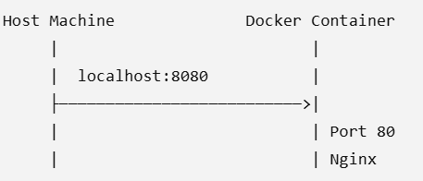
So:
Port | Meaning
8080 | Port on your computer
80 | Port inside Nginx container

12. Connect an Existing Container to a Network
You can also create a container first and connect it later.
Create another Ubuntu container:
docker run -it --name test-client ubuntu bash
Exit:
exit
Connect it to our network:
docker network connect my-network test-client
Verify:
docker network inspect my-network
test-client should now appear as a connected container.

13. Disconnect a Container
To remove the container from the network:
docker network disconnect my-network test-client
Verify:
docker network inspect my-network

14. Remove the Network
First remove the containers using the network:
docker rm -f web-server client test-client
Then remove the network:
docker network rm my-network
Verify:
docker network ls

Complete Example – Commands Together
For teaching/lab purposes, you can demonstrate the complete process with these commands:
# 1. Create network
docker network create my-network

# 2. Create Nginx container
docker run -d --name web-server --network my-network -p 8080:80 nginx

# 3. Create Ubuntu client
docker run -it --name client --network my-network ubuntu bash

# 4. Inside Ubuntu
apt update
apt install -y curl

# 5. Test Nginx using container name
curl http://web-server

# 6. Exit
exit

# 7. Inspect network
docker network inspect my-network
Then open:
http://localhost:8080

Final Architecture
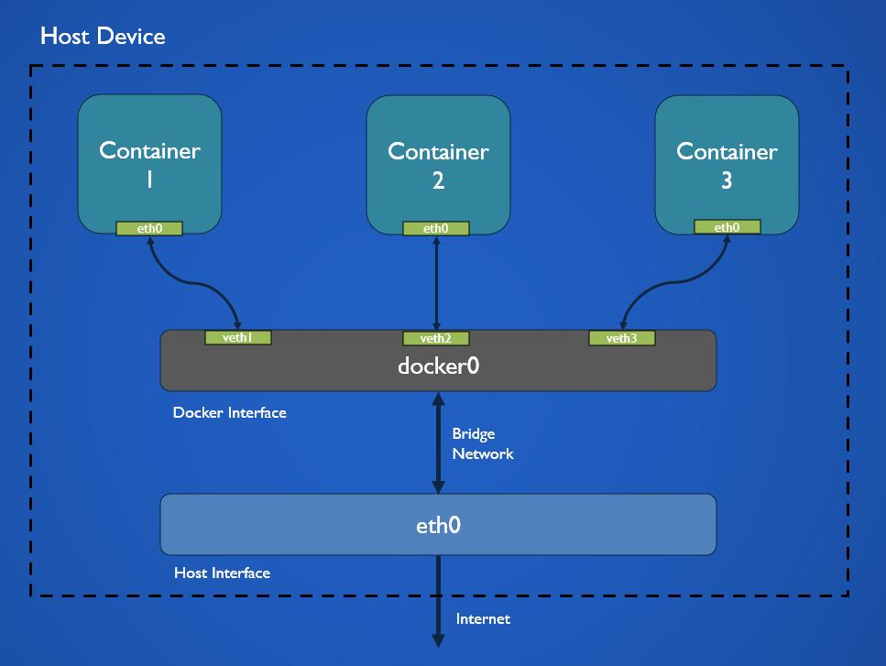
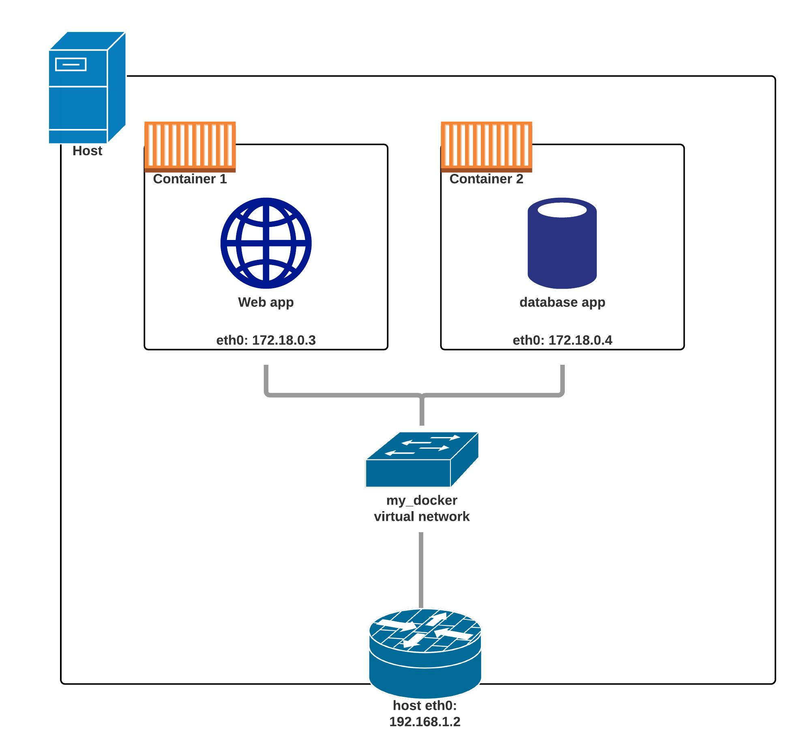
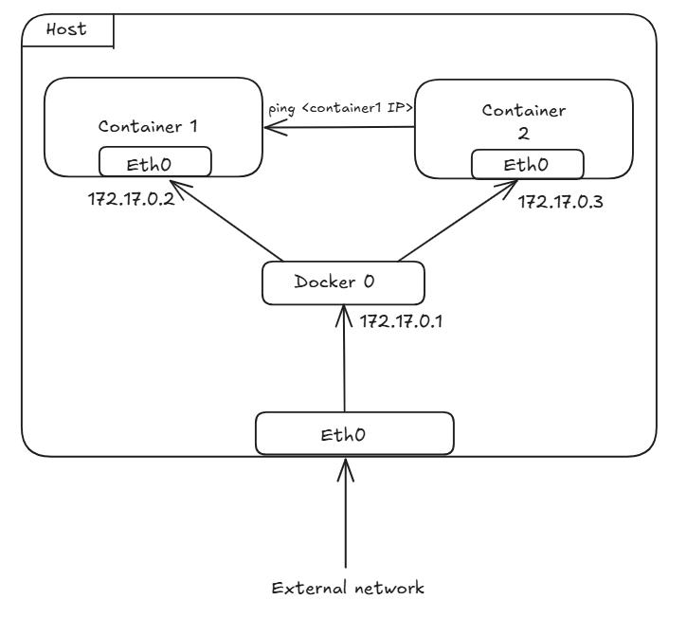
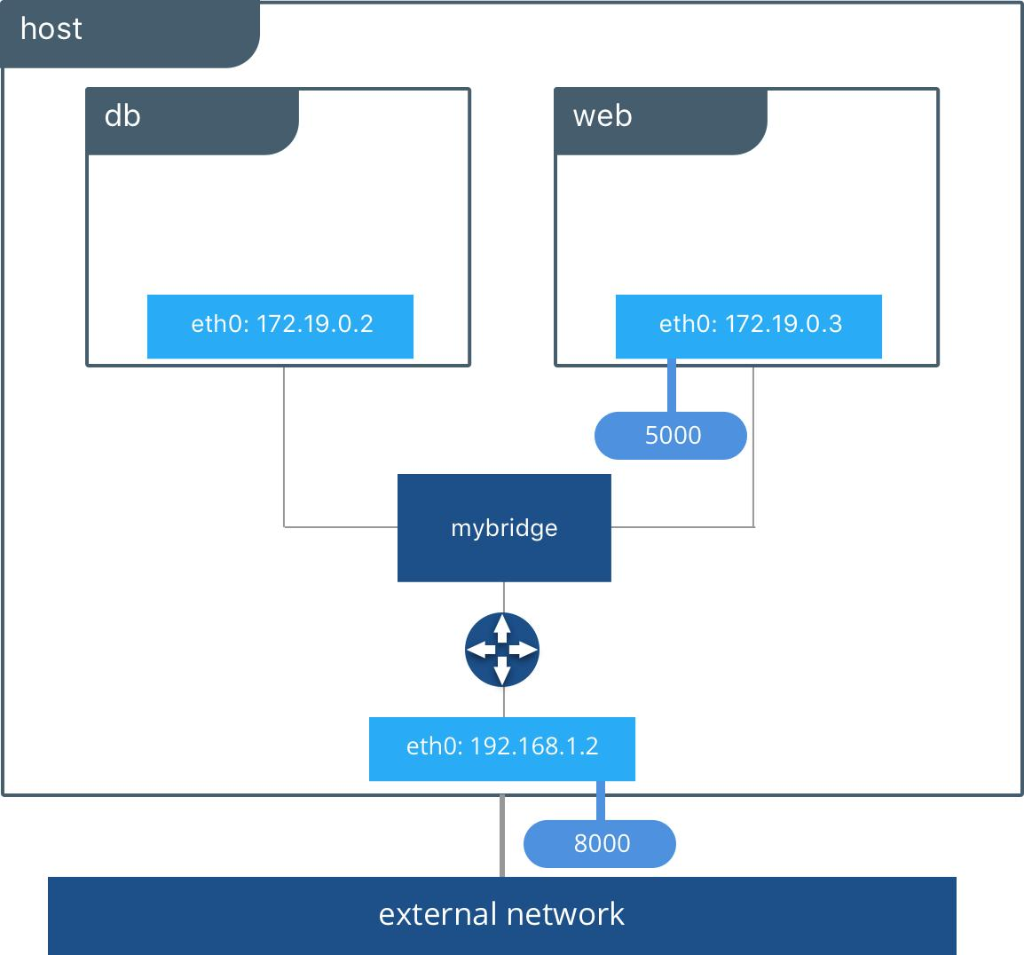

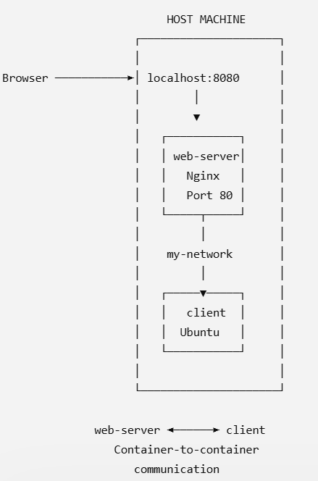

Key point to remember
Docker Network → Connect Containers → Containers communicate using names → Publish ports only when external access is required.
For example:


